Hi, there :)

This is Naomi, co-founder at cloudHQ. Thank you very much for downloading our Chrome extension: [Sync Google Drive™ with Dropbox, Box, ....](https://chrome.google.com/webstore/detail/sync-google-drive-with-dr/iobcbdgacfkninlcbphihhdlkobkehia)

This will be your first tutorial. All you have to do is click one button.

Do you see the “**Save to**” button on the top right of your screen?

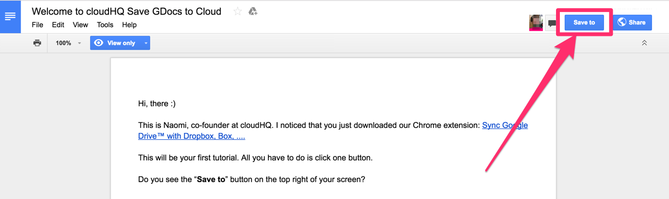

All you need to do is click it, and cloudHQ will prompt you to create an account and then select a cloud service where to save your Google document or spreadsheet: you can save to Dropbox, OneDrive, Box, etc. - even Evernote and Onenote.

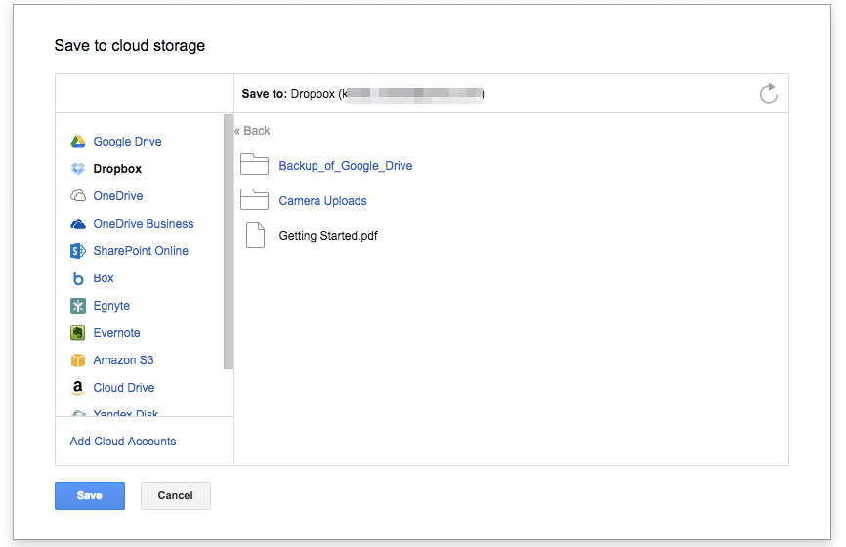

This will be a lifesaver for anyone who needs their Google documents or spreadsheets saved in some other cloud storage. Rather than manually downloading and uploading - this takes seconds.

Everything should be as easy as 1 click.

Naomi & the Team

|  |
| --- |
|  |

|  |
| --- |
|  |